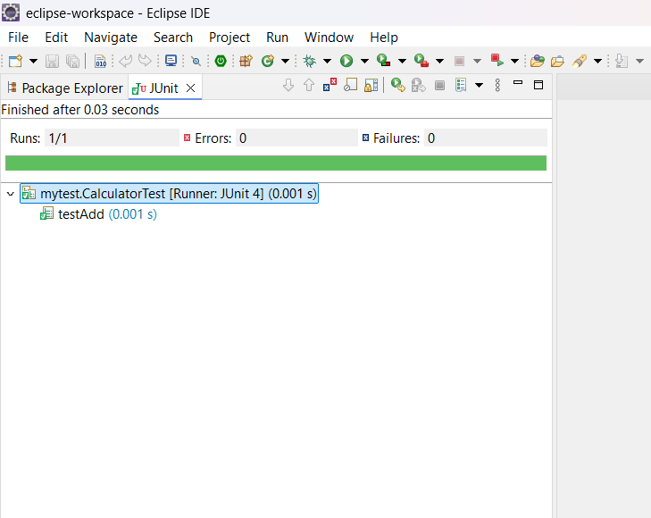Exercise 1: Setting Up JUnit

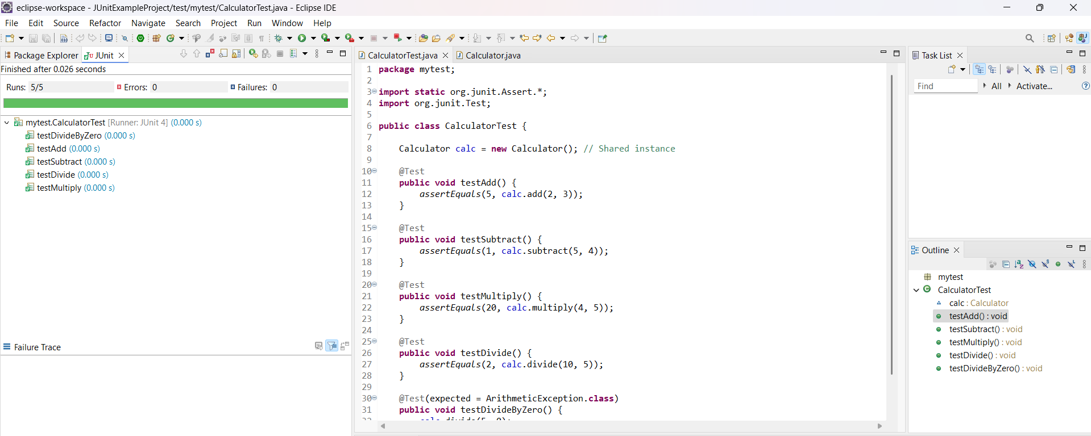Exercise 2: Writing Basic JUnit Tests

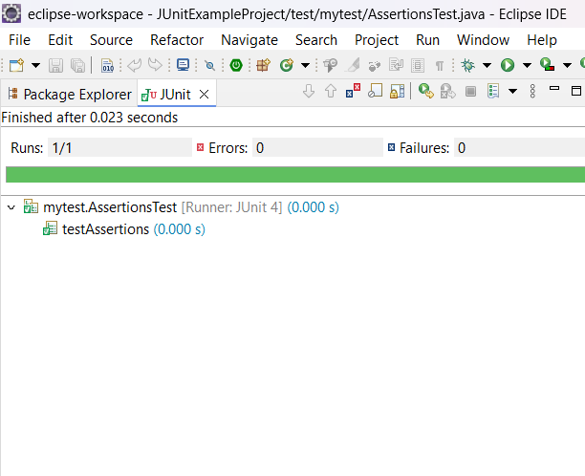Exercise 3: Assertions in JUnit

Exercise 4: Arrange-Act-Assert (AAA) Pattern, Test Fixtures, Setup and Teardown Methods in JUnit

